

**Principal’s Report**

**Zig Zag Christmas Carols**

Our carols evening will be taking place on **Monday 16th December starting at 5.30pm.** Come along and enjoy a BBQ, carols, chocolate wheel and join in what is always a lovely evening and a great way to end another wonderful year at Zig Zag School!

Don’t forget your picnic rug or chair.

 **Presentation Day**

Our annual Presentation Day Program will be taking place on **Tuesday 17th December commencing at 10.30am.** Please join us as we recognise the hard work and achievements of our students throughout the 2013 school year.

**Families are asked to please bring a plate to share.**

**Student’s Party**

Student Party day is **Wednesday 18th December**, the last day of the school year for students. Students are invited to wear Christmas Party Clothing.

As is the usual practice the P&C will be providing hot food and drinks for the children. We would ask that the students bring in food to share:

K/1: please bring fruit

2/3/4: please bring in something savoury

4/5/6: please bring in something sweet

**Children can wear mufti or Christmas clothing.**

**Christmas Hamper**

**We urgently require donations** for the P&C Christmas Hamper. If each child were to bring in just one small item of non-perishable food or a Christmas themed treat we would be very grateful. The hamper is to be used as one of the prizes in the raffle that will be drawn following the Presentation Day celebrations.

**Combined Schools Chocolate Wheel**

Thank you to all the families and students that came to support this great event. It was wonderful to see so many Zig Zag faces. Our students looked fantastic sitting together and enjoying the performances by other schools and it was great to see them singing in the combined schools carols. They gave a fantastic performance of ‘Keep On’ and received a huge applause from the audience.

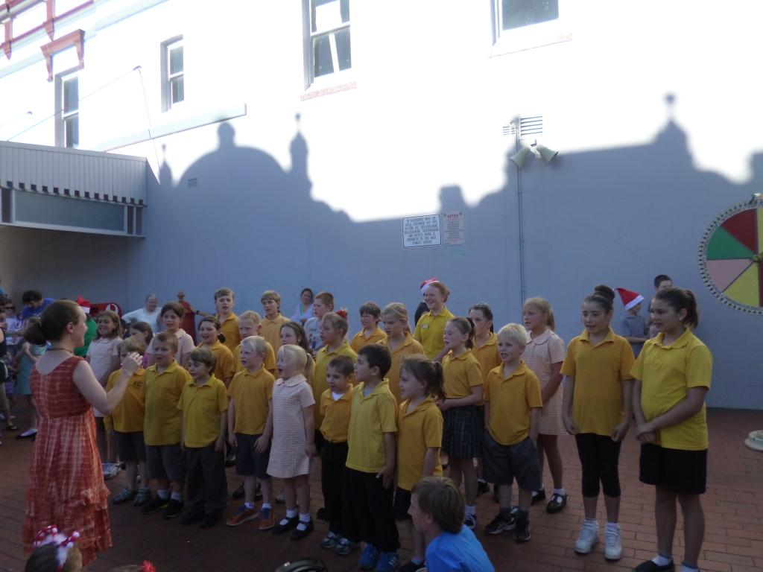

**Year 6 Farewell**

The Year 6 Farewell Dinner will be held on **Tuesday 17th December** at the Lithgow Workers Club from 6.00-7.30pm.

Thank you boys and girls for being such wonderful role models to the rest of the students, you have made me very proud!

**School Reports**

Semester Two reports will be sent home on **Monday 16th December.**

**School Dates 2014**

Wednesday 29th January – Year 1-6 first day

Thursday 30th January – Kindergarten first day

**SAKG Cook Books for sale**

The Cook Books that we have made with recipes from our SAKG program are now available to purchase for $15 from the school. They are a wonderful gift idea

**Studyladder for the holidays**

Studyladder has provided all students with free access to the NEW Christmas Resources, Holiday Games and Health and Safety Resources during the holidays.

Studyladder is a K-6 we based educational program designed by teachers. The program is curriculum based and covers Mathematics, Literacy and 8 other subjects. Your child has been given a username and password which can be used to access Studyladder at school and from home.

To access Studyladder from home go to [www.studyladder.com.au](http://www.studyladder.com.au) and login using your username and password.

**Ziggle Zaggle**

Our baby rhino sculpture has received his final coat of paint and we have set him free to join the stampede as part of Taronga Zoo's 'Wild Rhinos' event.

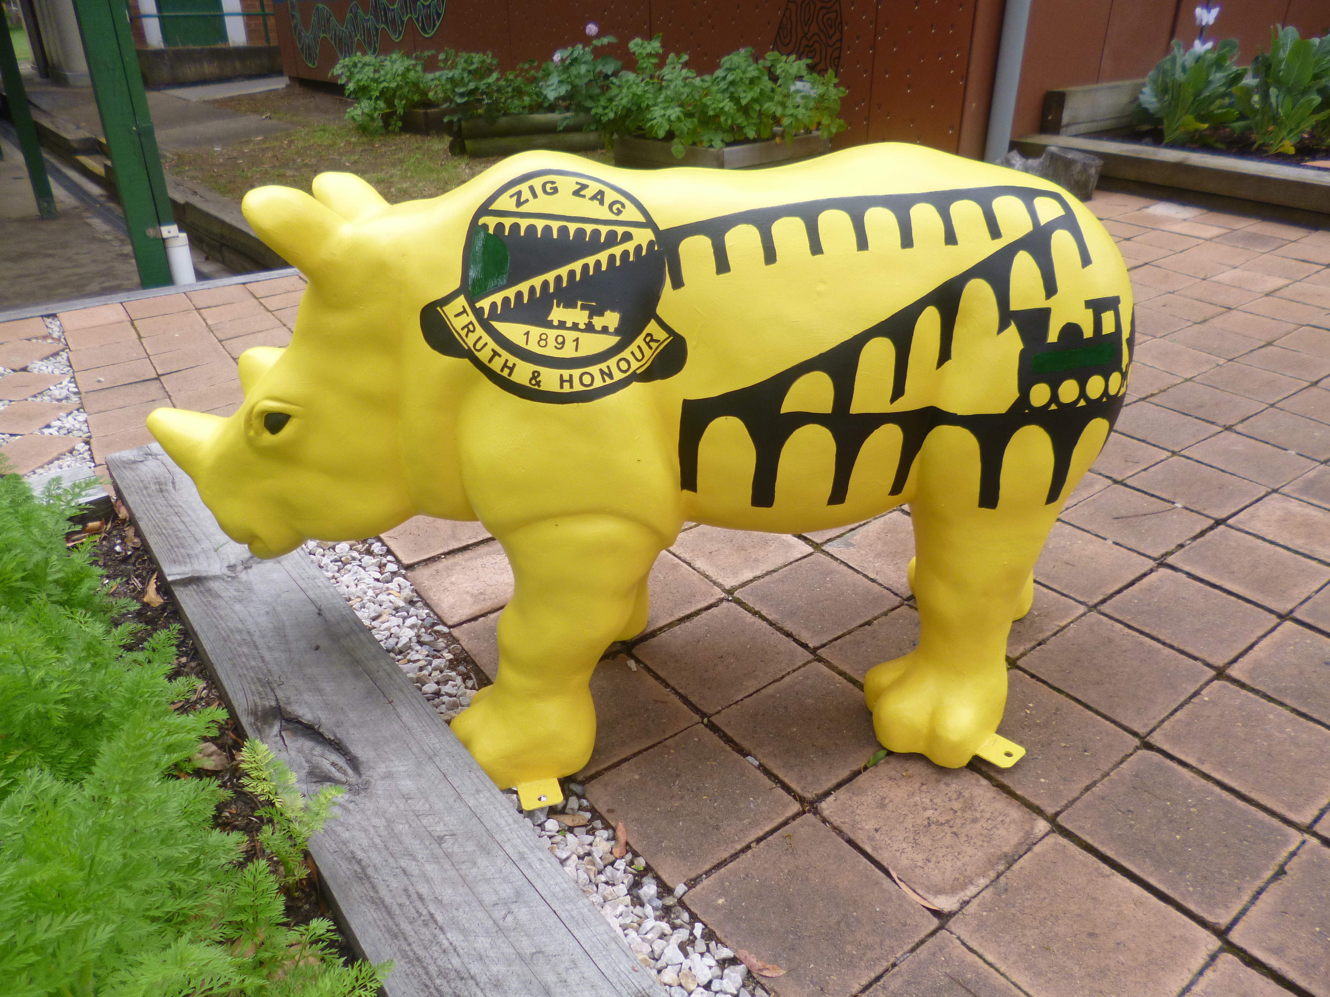

After brainstorming and voting the students have named our baby rhino Ziggle Zaggle.

The herd of wildly colourful rhino sculptures will be on display from February to April 2014, trailing from Sydney Harbour foreshore, the Blue Mountains to Dubbo and the Central West region of NSW. Raise awareness and funds for Taronga’s conservation projects.

Our students have been using our school wiki to engage in web based enquiry to learn about rhinos and how to protect them.

“It’s good fun because we can learn about rhinos. Our whole school likes to use the wiki.”

*Sarah Russell K/1*

“It’s cool. It’s fun. It’s cool because there are some videos and theres lot sof things to learn about Rhinos.”

*Joaquin Taylor K/1*

“You can learn about Rhinos. You find out information by clicking on the different parts.”

*Beyer DeBeuzivelle Howarth K/1*

“It’s a really good way to find out facts about all the types of rhinos in the world. My favourite part was asking questions and answering them on the forum.”

*Samara Morgan 2/3/4*

“It tells you about Rhinos. They are almost extinct. The chat was good because you can talk about Rhinos and ask questions with your friends and teachers.”

*Caleb Edwards 2/3/4*

“It gives you good information. I liked the discussion and finding out so much about rhinos.”

*Janaya Russell 4/5/6*

“It was fun answering questions and finding links on the wiki to more information on other webpages.”

*Ryan Merlino 4/5/6*

“It was creative and interactive and fun to talk to other students throught it.”

*Olivia Morgan 4/5/6*

**Basketball Clinic**

The primary children had a great afternoon last Friday participating in a basketball sports workshop. Richard and Adam Marjarham lead the children in drills and activities to build up their basketball skills.

**Captains Speeches**

Our Year 5 students did a wonderful job at presenting their Captians speeches on Tuesday. The rest of the school voted and the Captains and Vice Captains for 2014 will be announced at Presentation Day, next Tuesday.

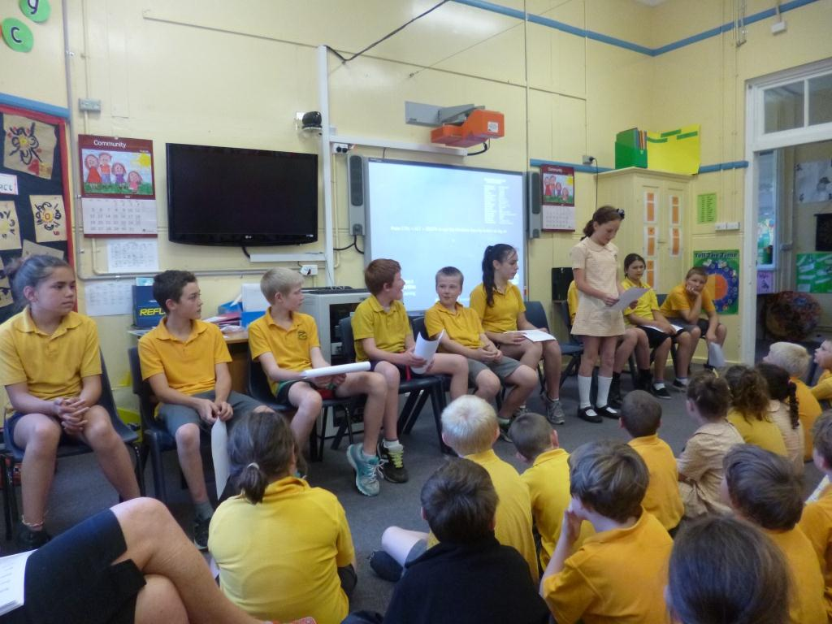

**Books for the Philippines**

***Food, they eat they forget.***

***Clothes, they wear and it will fade.***

***Books, they will have a new life.***

Due to the recent devastation caused by Typhoon Haiyan there are entire provinces in the Philippines without schools. Quite simply entire schools were washed away and all equipment destroyed. Books for the Philippines are seeking the assistance of Australian school communities in helping to gather equipment to send to the Philippines.

Please send in any 2nd hand books that are in good condition to be sent to the Philippines. The collection box is under the bench at the school office.

***Vicki Gillmore***

***Relieving Principal***

**COMMUNITY NEWS**

**Lithgow City Council presents The Wizard of Oz Christmas Show**

**“Santa joins the Oz Gang for a magical, interactive Christmas celebration. Have lots of fun with Santa’s elves, Rudolph, a talking Christmas tree and the Snow Fairy. Sing along to all your favourite Christmas songs and carols.”**

**Sunday 15th December 2013**

**10.30am – Lithgow Civic Ballroom (off Barton St, Lithgow)**

**3.00pm – Crystal Theatre (Wolgan St, Portland)**

**FREE ENTRY – Bookings 1300 760 276**

|  |
| --- |
| 6a00e0097e4e6888330120a6067edb970c-150wi  **Red Cross Mobile Blood Donation Centre**  The Australian Red Cross Mobile Blood Service is visiting **Lithgow Bowling Club,** Peachman Ave  Monday 16 December, **1:00pm - 7:20pm**  Tuesday 17 December, **8:00am - 2:40pm** Wednesday 18 December, **1:00pm - 7:20pm** Thursday 19 December, **8:00am - 2:40pm**  If you haven't already made an appointment to give blood, you can [make an appointment online](https://staffowa.det.nsw.edu.au/owa/redir.aspx?C=8f45c0ce9bbc46cab082610b5e3b227b&URL=http%3a%2f%2fdonors-newsouthwales.cmail1.com%2ft%2fr-i-kkuhnt-yudkoiuik-u%2f) or call us on **13 14 95**.  1 in 3 Australians will need blood, but only 1 in 30 donates. Donated blood helps cancer patients, people with blood disorders, mothers-to-be and newborn babies, as well as trauma and surgical patients. |

|  |
| --- |
| **P&C News**  **Zig Zag Carols Evening** Our carols will be held on the Monday 16th December from 5.30 – 8.30pm in the school grounds.  **Christmas Hamper Donations**  Please send in donations for the hamper to the office. The hamper will be one of the prizes in the raffle that will be drawn after the Presentation Day celebrations on Tuesday 17th December.  0tk12[1]  The P&C would like say thank you to all parents and carers for their support throughout the year.  All of our programs and events would be impossible without your support. We will see you all in the 2014 school year. |

